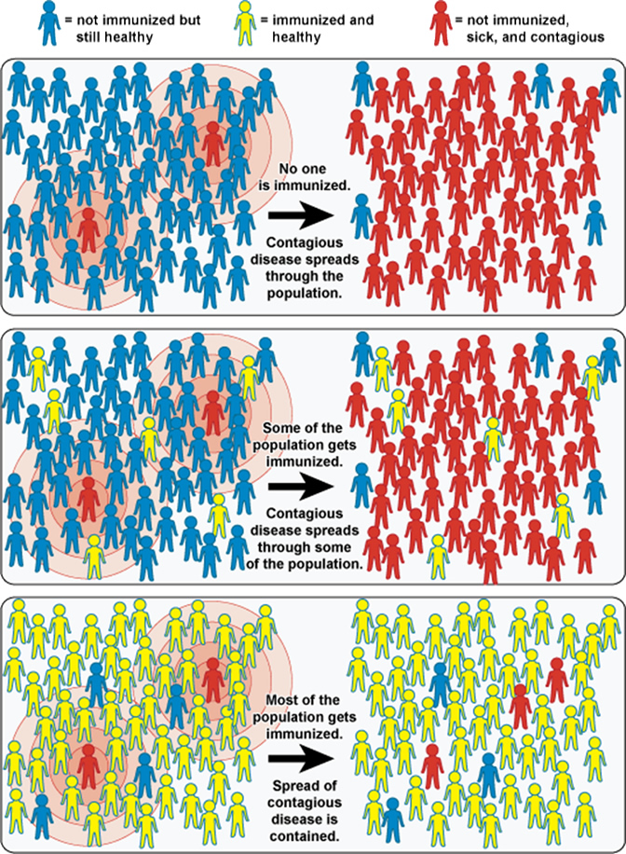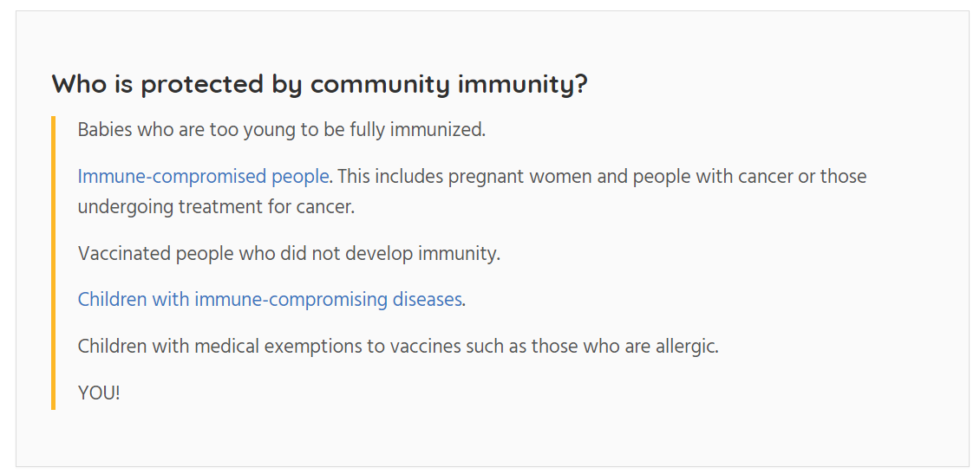

Herd (Community) Immunity

* If enough people in the population are vaccinated and immune, disease can’t spread: the vaccinated people are a barrier or shield that prevents disease spreading through the community effectively.
* Helps people who can’t be vaccinated, or for whom vaccines don’t provide adequate immunity.